Omni Bedford Springs Resort

Photos Virtual Tour

2138 Business 220
Bedford, Pennsylvania 15522
Phone: 814-623-8100, Fax: 814-623-8052

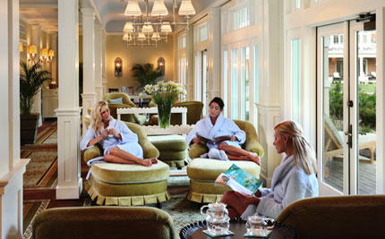
Be Pampered at Springs Eternal Spa - Bedford Springs, PA

Springs Eternal Spa, a 30,000-square-foot destination spa, is one of the few spas in the country utilizing natural spring water in all of its treatments. The spa's treatments are inspired by the resort's eight mineral springs, first used by the local Native Americans for their healing properties. Sample the historic "Bedford Baths" using our signature indigenous product line inspired by local herbs and botanicals. Unwind with a soothing massage, beauty treatment; or simply spend a few moments in the serene spa garden. Step inside our resort spa getaway for a classic American spa experience and check our special offers page for great resort spa packages.

Spa Services

View our spa brochure, pricing guide and spa menu. We advise you to make reservations 4 - 6 weeks in advance, prior to visit.

Springs Eternal Therapeutic Massage
This therapeutic massage is tailored by the therapist to meet the needs of each individual guest. It is designed to increase circulation, relieve muscular tension, and promote relaxation. This massage is customized for each guest with a range of Swedish to Deep Tissue pressure.

- Featuring Natural Mineral Springs
- Massage Services
- Body Treatments
- Hydrotherapy
- Facial Services
- Manicure & Pedicures
- Famed "Bedford Cure" & Bedford Baths

Please contact Springs Eternal Spa reservations specialist directly at 814-624-5633 to make spa reservations.

- Local Herbs, Minerals & Waters
- Large Whirlpool Areas
- Shower & Steam Room
- Couples' Treatments
- Private Spa Garden
- Men's & Ladies' Locker Facilities
- Boutique Shops featuring unique and carefully selected products
- Private Yoga Instructions
- Private Pilates Instructions
- Private Hikes
- Guided Stretch and Hike

