Omni Bedford Springs Resort
Photos Virtual Tour
2138 Business 220
Bedford, Pennsylvania 15522
Phone: 814-623-8100, Fax: 814-623-8052

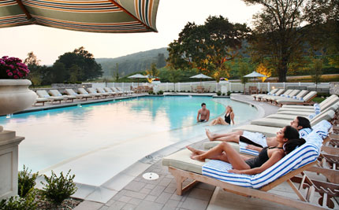
Pools and Fitness
In 1905, Bedford Springs Resort made debut of one of the first indoor pools in the United States. Now you can experience this sparkling gem, fully restored to its lavish beauty. Once upon a time, musicians would serenade the swimmers from an elevated opera box, and legend has it that daring sons of visiting dignitaries would plunge into the two-story pool from its upper level. Today, you can simply dip into the peaceful waters and relax.
- Heated Spring-Fed Indoor Pool
The heated spring-fed pool is open for swimming year-round.
- Outdoor Pool
During warmer months, unwind in our alluring outdoor pool and whirlpool overlooking the lush Cumberland Valley. Lined with private, tented cabanas, the outdoor pool is a refreshing escape for visitors of all ages. Also offering The Turtle Shell, a poolside snack bar for your enjoyment.
Get energized with a visit to our state-of-the-art fitness facility. Reach your target heart rate with our cardio machines, or clear your mind with a yoga class in our movement studio. Featuring the latest Cybex equipment and professional staff, the fitness center will rejuvenate you in a matter of minutes.
- Cybex cardiovascular equipment
- Cybex weight training equipment
- Movement studio

