Omni Bedford Springs Resort
Photos Virtual Tour
2138 Business 220
Bedford, Pennsylvania 15522
Phone: 814-623-8100, Fax: 814-623-8052
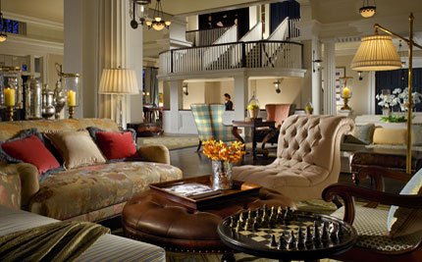
The Omni Bedford Springs Resort preserves the charm and legacy of Pennsylvania's luxury resort destination providing first class services and amenities including Springs Eternal Spa, incorporating treatments with mineral waters; and our legendary 18 hole golf course. Other resort staples include our swimming pools and fitness center as well as outstanding dining options, meeting and conference rooms and wedding locations.

Fitness and Leisure
- 30,000 square foot Springs Eternal Spa
- Full service health club open 24 hours a day
- Movement Studio
- Morning Yoga Classes
- Private Pilate Lessons
- Private Yoga Lessons
- Heated indoor spring-fed pool (open year round)
- Outdoor pool and whirl pool overlooking Cumberland Valley (seasonal)
- Private cabanas
- 18 hole Golf Course
- Indoor Resort Activities
- Scavenger Hunts*
- Historic Tours*
- Anderson Explorers Kids' Day Camp*
- Cooking Classes/Demos ($30 for cooking with the chef)
- Sunrise Yoga Classes (Thu-Sun)*
- Private Pilates Instructions
- Private Yoga Instructions
- Outdoor Resort Activities
- Hiking Trails
- Guided Hiking and Biking*
- Seven Springs Stretch Guided Hike (Thu-Sun)*
- Stock Fishing at Red Oak Lake
- Shober's Run Fly Fishing
- Fly Fishing Classes*
- Geocaching
- Horse Shoes
- Bocce Ball
- Badminton
- Volleyball
- S'mores at the Fire Pit
- Nature Hikes/Bird Watching
- Paintball (off-site)*
- Tennis
- On-site Retail
* Additional fees will apply. Please contact the Concierge Staff for all details, (814) 624-5642.
- Bedford Market: The official gift shop featuring the work of local artists, books and videos detailing our storied property and sundry items. A visit to the Bedford Market will give you a true appreciation for the culture that is unique to Bedford, PA.
- Tally Ho Sport: The hotel's sport shop offers hiking, biking, swimming, fishing and recreation items for you to enjoy while at the hotel.
- Elaine's Wearable Art: Features Distinctive Collections of Artisan Jewelry, creative apparel and special accessories all hand selected for your shopping pleasure. Headquarter store is located in downtown Bedford.

Guest Services
- The Power of One® - Excellence in Service
- 24 hour business center
- Concierge services
- Full service restaurant
- High-speed wireless Internet access throughout resort
- Kids Program coordinated by Adventures in the Alleghenies
- Pet Policy available - please call reservations for details and deposit information
NOTE: A $15.00 per-room, per-day resort fee will be added to the daily room rate (this is a special rate for NMAPC guests). This resort fee allows guests to enjoy many resort services and activities without having to incur miscellaneous charges.

Transportation and Parking
- Valet parking included in resort fee

